Restore a Database Backup Using SSMS

1. Open Microsoft SQL Server Management Studio
2. In **Object Explorer**, connect to an instance of the SQL Server Database Engine and then expand that instance
3. Right-click **Databases** and select **Restore Database...**
4. On the **General** page, use the **Source** section to specify the source and location of the backup sets to restore
5. Select **Device.** Click the browse (**...**) button to open the ‘**Select backup devices’** dialog box
6. On the ‘**Select backup devices’** dialog box click **Add and add Database.bak file**
7. Database file can be downloaded with other project files from Git. It is called **Database.bak**. Add this file to   
   \Program Files\Microsoft SQL Server\MSSQL14.SQLEXPRESS\MSSQL\Backup
8. Click **OK to close ‘Select backup device’ dialog box**
9. **Click OK to close ‘Restore Database’ dialog box   
   ‘Advertisement’ database appears in Object Explorer under Databases.**

Create a Database User

1. Open Microsoft SQL Server Management Studio
2. In the **Object Explorer**, in connected Database Engine, right click on **Security** folder and select **New** 🡪 **Login**
3. In the ‘Login-New’ dialog box, on the **General** tab
   1. Specify ‘**Login’** name (for example, *application*)
   2. Select ‘**SQL Server authentication’**
   3. Specify and confirm the **password** (for example*, Portal1!* )
   4. Unselect **Enforce password policy**

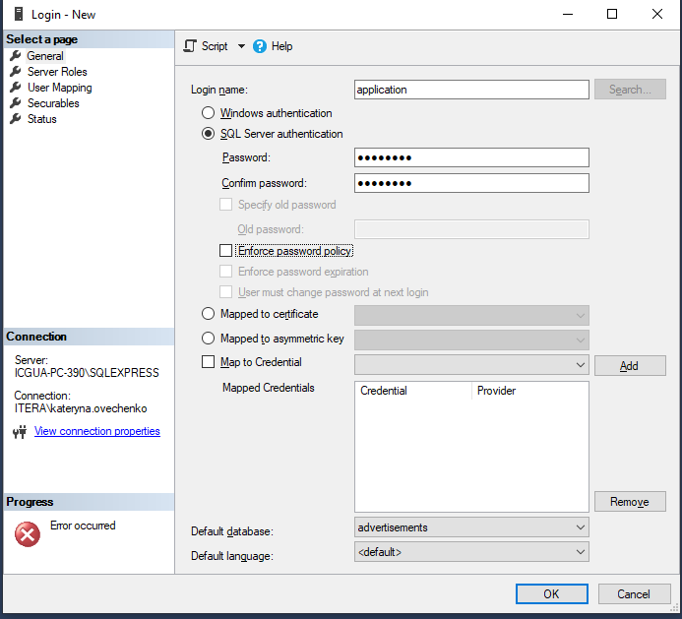

1. Go to **User Mapping** tab (left pane in the same dialog). On **User Mapping** tab
   1. In the table ‘**User mapped to this login’** check ‘advertisement’ database. Your login appears in the ‘User’ column
   2. In the ‘**Database role membership’** select
      * db_ddladmin checkbox
      * db_owner checkbox
      * public checkbox

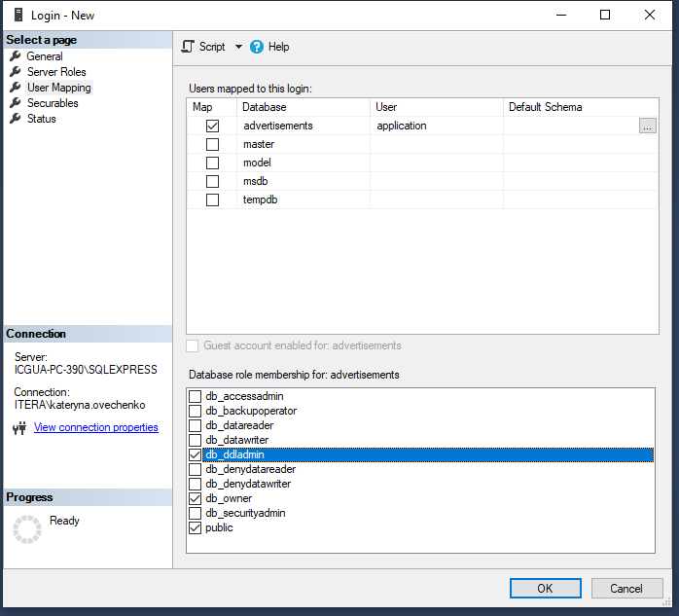

1. Click **OK** to close ‘Login – New’ dialog.
2. Right click the database engine connected in the **Object Explorer** window (Database engine is called ICGUA-PC-390/SQLEXPRESS /SQL Server 14.0.1000 – application on the screenshot below) and select **Properties**

1. On the ‘**Server Properties’** dialog box, select **Security** **tab** from left menu. On the Security tab
   1. In the **Server Authentication** section switch to **SQL Server Authentication mode**
   2. Click **OK** to close ‘Server Properties’ dialog
2. Close Microsoft SQL Server Management Studio.
3. To apply new settings, we need to restart SQL Server. In order to do this, open **Windows Services** (type Services in the windows search).
   1. Select **SQL Server** **(SQLEXPRESS)** service
   2. Click **Restart** the service in the left menu
4. Login to SQL Server with new credentials
   1. Open Microsoft SQL Server Management Studio
   2. In the **Object Explorer** select **Connect** 🡪 **Database Engine**
   3. Set **Authentication** to ‘SQL Server Authentication’
   4. Enter **Login** and **Password** specified when you created a user (step #2 in this instruction)
   5. The user is logged in into the Advertisement database.

Run Application

1. Unzip all 5 archives with names API.zip.001 – API.zip.005 to one folder
2. Open file **appsettings** for **edit as administrator**. Change the following parameters in the file:
   1. **Server** = <name of database engine> (for example, ICGUA-PC-390\\SQLEXPRESS from instructions examples).

Note: if the name of database engine has \ symbol, then it should be replaced with \\ in the Server parameter in appsettings file.

* 1. **UserId**=<user login to database> (for example, application from instructions examples)
  2. **Password** = <password to login to database>
  3. Save changes

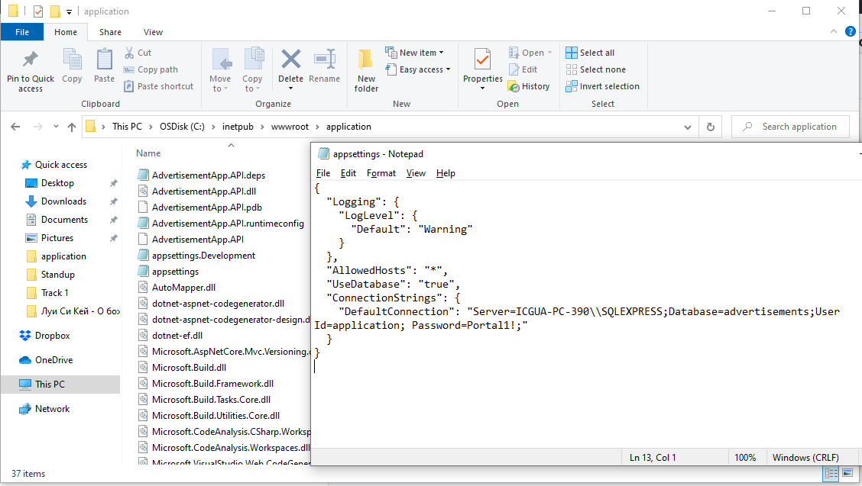

1. Run AdvertisementApp.API.exe. Console window opens and application starts. Do NOT close this console window while working with application.
2. Open browser and enter [**http://localhost:5000/api/index.html**](http://localhost:5000/api/index.html). You should now see the Swagger page with list of APIs from the application

Setup Postman project

1. Open **Postman** application
2. Click **File 🡪 Import**. Select the following files from downloaded project
   1. **‘Postman Collection’** with list of requests
   2. **‘Postman variables.postman_environment’** with environment variables
   3. **‘Postman Workspace.postman_globals’** with global variables
3. You are all set!